Databasing Type Specimens on the RDE Form
Complete your RDE form as normal, then in the Notes field put in the following information relevant to your specimen ie:
HOLOTYPE Formicidae fred, Meier 2013
Note that the genus and species name may be different to the Identification genus and species due to synonomy, so make sure you use the identification from the Type label itself.

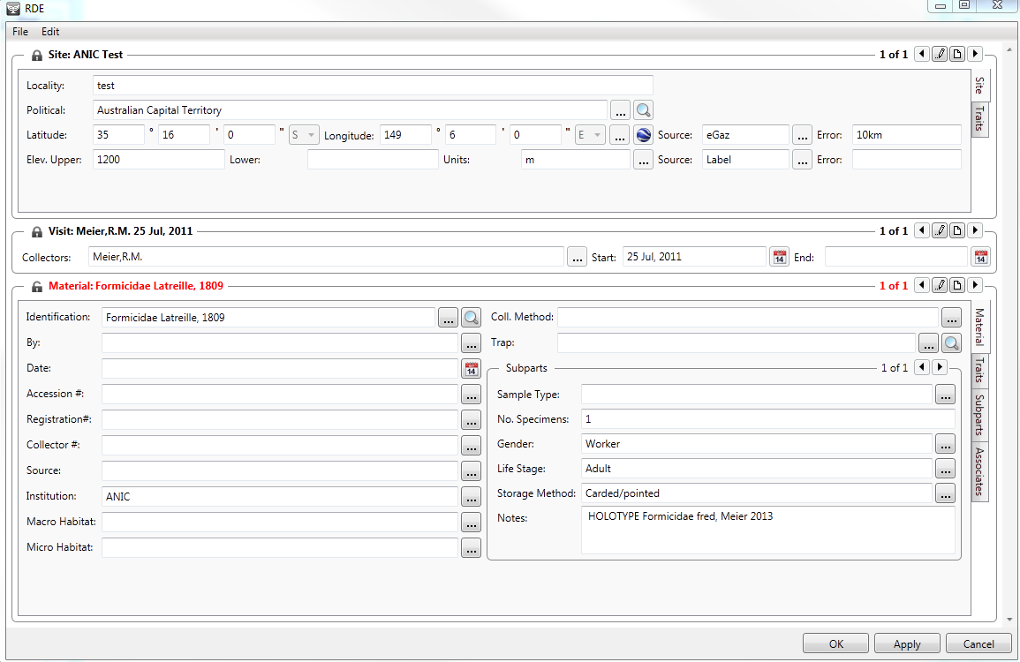

Now click on the Traits tab of the same RDE Form,
Click on Add trait in bottom left corner of Traits tab
A pick list called Choose a trait type will appear. The fastest way to navigate this pick list is to just hit the letter T on your keyboard, the pick list will automatically move and highlight Type Status, now just hit the enter key on your keyboard and the Type Status trait will be added to your Traits tab.
Now add the New Trait Value by using the pick list, so in the case of this example you would choose holotype. Please note that if you type the information into the New Trait Value and don’t use the pick list, any typing errors will be stored in the pick list for possible future use and this may perpetuate the same error, so you are encouraged to use the pick list and it is less key strokes to do so.
Now click on Add comment in the top right corner of the Traits tab. You can now type the specimen identification information into this field ie Formicidae fred, Meier 2013.

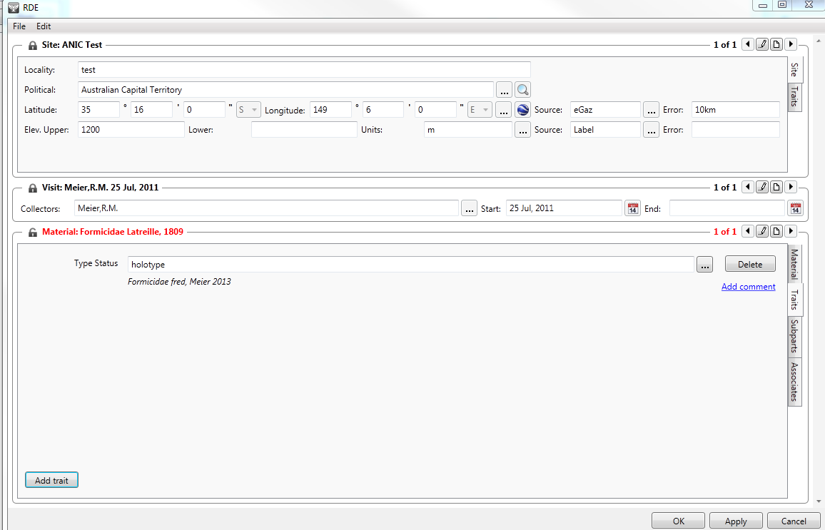

Now Apply and Ok to save your RDE Form and the Type Status has been completed.

